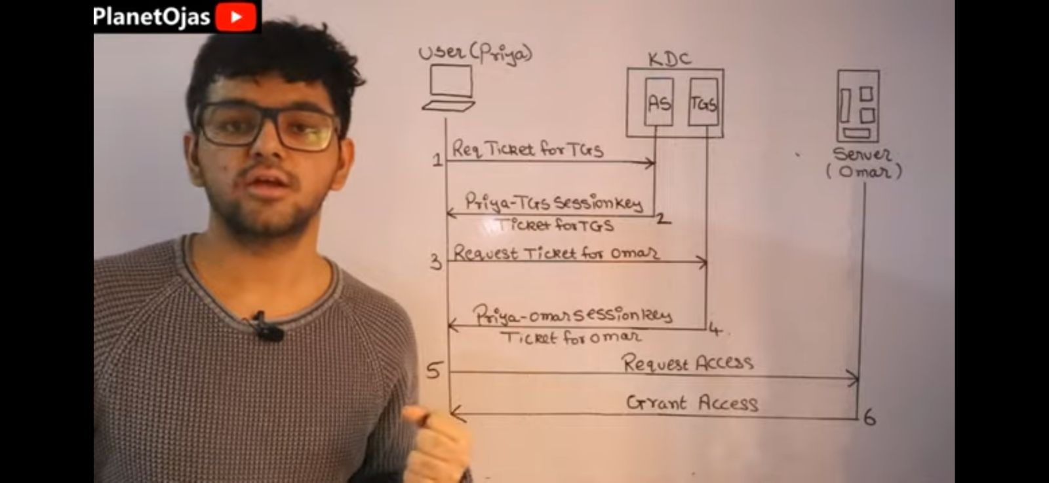

**build a collection between user to server first user surpass a authentication to reach server thats called kerberos....anyone from these two may have to do be autheticate but i am giving example of between client and server**

**in kerberos first user have to proof that he is valid so first he sent a request in As...then As check his table to match the identity if he become valid then he go to tgs to ask for a ticket for server then tgs give him ticket then finally he sent a request for server acces to server and server reply with grant**